Experiment No. 5

Title: Modelling Behaviour – Use Case Diagram and Interaction Diagram using UML

Batch: B2 Roll No.: 1714097 Experiment No.: 5

Aim: To model Behaviour – Use Case Diagram and Interaction Diagram using UML ___________________________________________________________________________
Resources needed: IBM Rational Rose/Open Source UML Tool
___________________________________________________________________________

Procedure:
Prepare mentioned behavior diagrams for chosen problem using Rational Rose/ any other Open Source UML tool.
___________________________________________________________________________

Results: Printout of mentioned behavior diagrams
Use Case diagram:
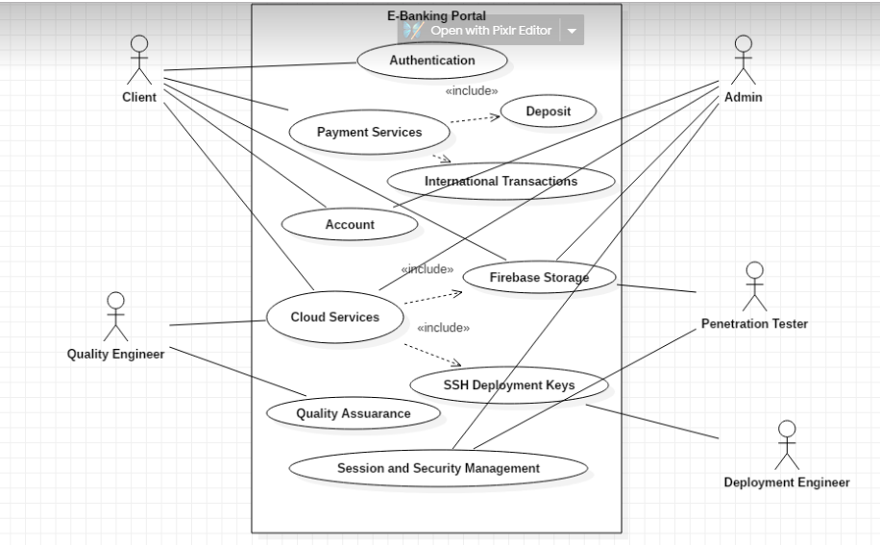

Interaction Diagram:
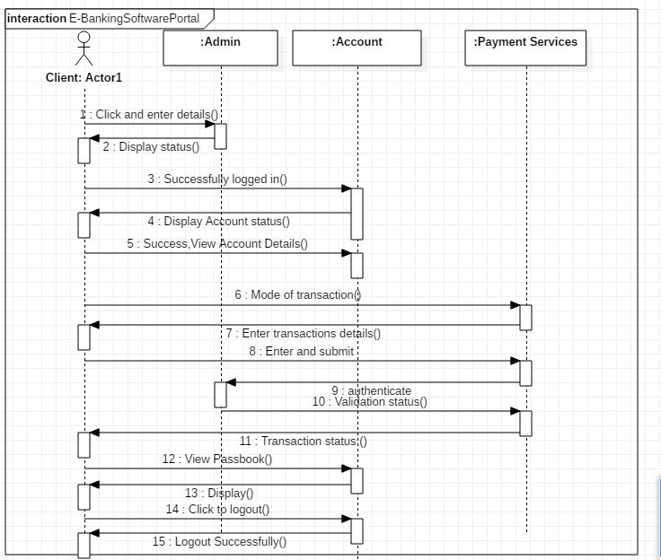

____________________________________________________________________
Questions:

1. In a use case diagram, relationships between different actors are normally shown.
True False

Ans: True

2. A Communication diagram specifies a scenario.
True False
Ans : True
___________________________________________________________________________
Outcomes: Model the requirements using UML.
___________________________________________________________________________
Conclusion: Successfully understood and build the modelled Behaviour – Use Case Diagram and Interaction Diagram using UML.

Grade: AA / AB / BB / BC / CC / CD /DD

Signature of faculty in-charge with date
___________________________________________________________________________
References:

Books/ Website:
1.Michael Blaha, James Rumbaugh, “Object-Oriented Modeling and Design with UML”, Prentice-Hall of India, 2nd Edition
2. Mahesh P. Matha, “Object-Oriented Analysis and Design using UML”, Prentice-Hall of India
3. Timothy C Lethbridge, Robert Laganiere, “Object-Oriented Software Engineering – A practical software development using UML and Java”, Tata McGraw-Hill, New Delhi.
4. http://www.uml-diagrams.org/uml-23-diagrams.html
5. http://vlabs.iitkgp.ernet.in/se/

